**Australian Islamic College 2021**

**ATAR Chemistry Units 3 and 4**

**Task 1 (Weighting: 3%)**

**Equilibrium Test**

Test Time: 35 minutes

Please do not turn this page until instructed to do so.

|  |  |
| --- | --- |
| **First Name** | **Surname** |
|  |  |

|  |
| --- |
| **Teacher** |
|  |

|  |  |
| --- | --- |
| **Mark / 30** | **Percentage** |
|  |  |

Equipment allowed: Pens, pencils, erasers, whiteout, rulers and non-programmable calculators permitted by the Schools Curriculum and Standards Authority.

**Special conditions**:

2 marks will be deducted for failing to write your full name on this test paper.

**Teacher help**: Your teacher can only help you during your test in one situation.

If you believe there is a mistake in a question show your teacher and your teacher will tell you if there is a mistake in the question and if appropriate, how to fix that mistake.

**Spelling of Science words** must be correct. Unless otherwise indicated, science words with more than one letter wrong (wrong letter and/or wrong place) will be marked wrong. The spelling of IUPAC names must be exactly correct.

Unless otherwise stated, **equations** must be written balanced and with correct state symbols or they will be marked wrong.

For questions worth more than one mark involving calculations, your working out must be shown. Calculations that can not be easily understood by the marker or do not follow a logical sequence from top of the page to the bottom of the page will lose marks.

Follow-on marks will not be paid.

Questions must be answered in this booklet.

1. For the following **unbalanced** reaction the magnitudes of Kc are given.

Reaction: N2(g) + H2(g) ⇌ NH3(g)

Value of Kc at 25 oC = 3.3 x 108

Value of Kc at 177 oC = 2.6 x 103

Is this reaction exothermic or endothermic? Explain how you know by referring to the information given here.

(4 marks)

1. The following equation represents the reaction between chlorine gas and carbon monoxide gas.

Cl2(g) + CO(g) ⇌ COCl2(g) ΔH = −108 kJ mol−1

The concentration–time graph below represents changes to the system.

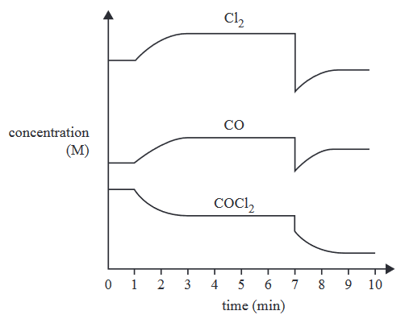

On the blank graph below draw a reaction rate – time graph for the same reaction as above for the time interval 0 to 4 minutes. Add an appropriate scale to the X (horizontal) axis. Label the reaction rate curve/s you draw.

(6 marks)

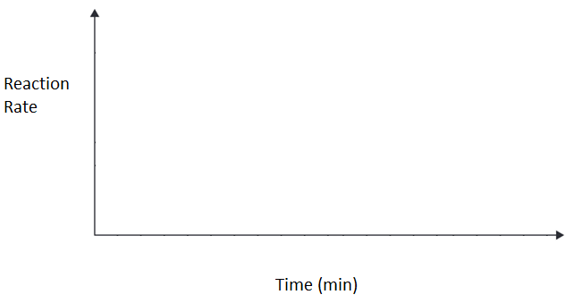

1. Nitrogen dioxide, NO2, and dinitrogen tetroxide, N2O4, form an equilibrium mixture represented by the following equation:

2NO2(g) ⇌ N2O4(g) ΔH = −57.2 kJ mol−1

NO2 is a brown gas and N2O4 is a colourless gas.

A change was made at time t1 to an equilibrium mixture of NO2 and N2O4, which achieved a new equilibrium at time t2. A graph showing the rate of the forward reaction is shown below. The original colour of the equilibrium mixture was light brown.

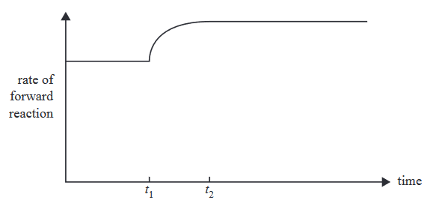

State what happened to the colour of the equilibrium mixture from t1 to t2, given that the temperature of the system changed at t1. Explain how you know this.

(5 marks)

1. Methanol is a very useful fuel. It can be manufactured from biogas. The main reaction in methanol production from biogas is represented by the following equation and energy profile:

CO(g) + 2H2(g) ⇌ CH3OH(g)

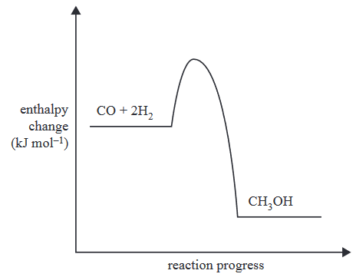

Complete the table below by stating how the stated changes made to an equilibrium mixture of this reaction would affect the value of Kc and the equilibrium yield.

(1 mark per correct line; no part marks; 3 marks total)

|  |  |  |
| --- | --- | --- |
|  | Effect On Value of Kc (Increase/Decrease/ No change) | Effect On Equilibrium Yield  (Increase/Decrease/ No change) |
| Addition of a catalyst |  |  |
| Increase in temperature |  |  |
| Increase in pressure |  |  |

1. The following concentration–time graph refers to a mixture of three gases, P, Q and R, in an enclosed 5.0 L container. At time t1 the mixture is heated.

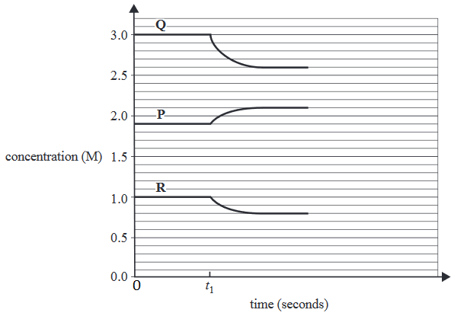

* 1. Given that the forward reaction is exothermic, write a balanced equation for the reaction with state symbols.

(1 mark)

* 1. State the equilibrium expression for the reaction.

(1 mark)

* 1. Referring to the same reaction as in part (a) of this question, state four ways of pushing this reaction to the right.

(4 marks)

1. Given below is the energy profile of a particular reaction.

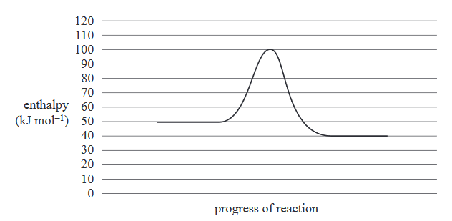

* 1. For the reverse of the reaction above, what is the value of the activation energy? Indicate if your answer is positive or negative with either ‘+’ or ‘-‘.

(1 mark)

* 1. For the reverse of the reaction above, what is the value of ΔH? Indicate if your answer is positive or negative with either ‘+’ or ‘-‘.

(1 mark)

1. The cobalt(II) tetrachloride ion, CoCl42−, dissociates into the cobalt(II) ion, Co2+, and chloride ions, Cl−, according to the following chemical equation.

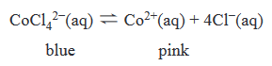

Five drops of silver nitrate, AgNO3, solution are added to the equilibrium mixture at time t1. A concentration–time graph for this reaction is shown below for times between zero and t1.

Continue the graph to show the changes that occur to the system from t1 until equilibrium is re-established.

(4 marks)

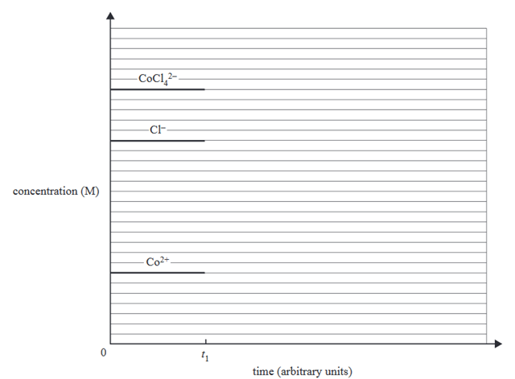

END OF TEST